 

**Model Development Phase Template**

|  |  |
| --- | --- |
| Date | 10 July 2024 |
| Team ID | 739893 |
| Project Title | Sepsis Survival Minimal Clinical Records |
| Maximum Marks | 4 Marks |

# Initial Model Training Code, Model Validation and Evaluation Report

This initial model training code will be showcased in the future through a screenshot. The model validation and evaluation report will include classification reports, accuracy, and confusion matrices for multiple models, presented through respective screenshots. **Initial Model Training Code**



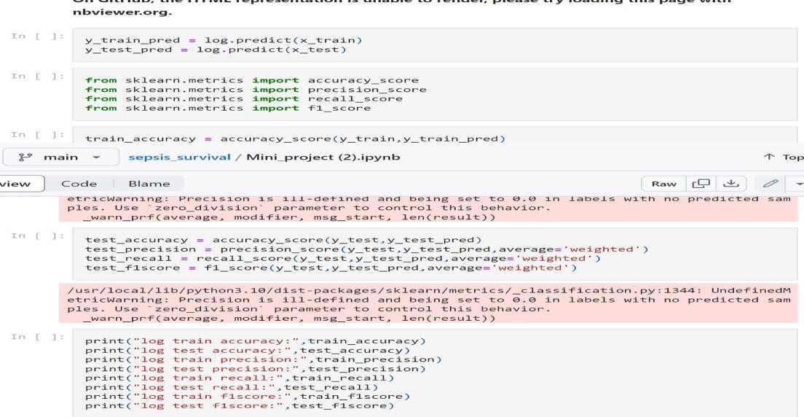

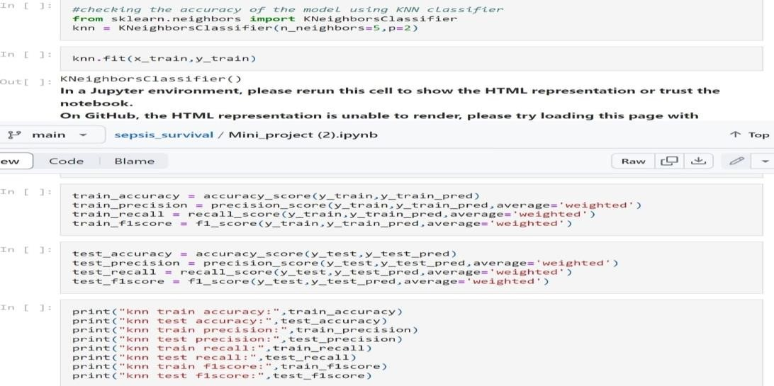

 

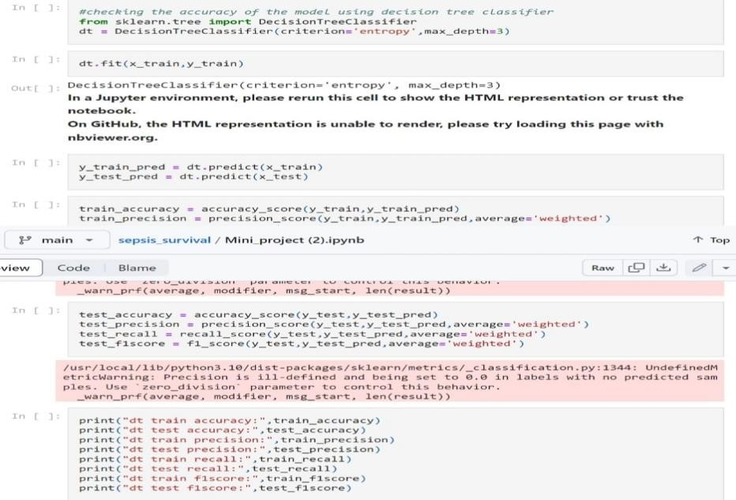

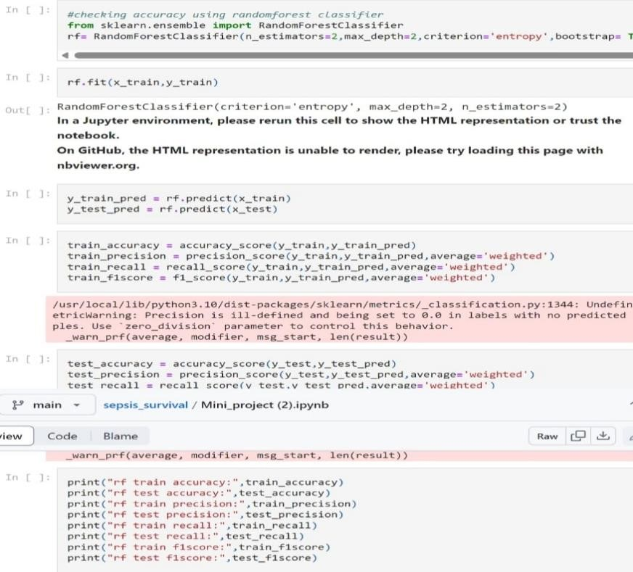

 

# Model Valuation And Evalution Report

|  |  |  |
| --- | --- | --- |
| **Model** | **Classification Report** | **F1 Score** |
| KNN |  | 88% |
| Random Forest |  | 89% |
|  |  |  |
| Decision Tree |  | 89% |
| Logistic Regression |  | 89% |